W6 - PRACTICE
Props – List display

 At the end of this practice, you should be able to…
- Display names dynamically, using curly braces {xx}
- Display a list of data
- Display images dynamically
- Pass data to nested components using props

 How to work?
- Download the start code from the Google classroom
- For each exercise you can either:
  - Run npm install
  - Or move an existing node_modules to the exercise folder (fastest option!)

How to submit?
- Create a repository on GitHub with the name of this practice:
Ex: C2-S1-PRACTICE
- Push your final code on this GitHub repository (if you are lost, follow this tutorial)
- Finally, submit on Google classroom your GitHub repository URL
Ex: https://github.com/thebest/ C2-S1-PRACTICE.git

 Are you lost?
You can read the following documentation to be ready for this practice:
https://www.w3schools.com/react/react_jsx.asp
https://www.w3schools.com/react/react_props.asp
https://www.gatsbyjs.com/docs/how-to/images-and-media/importing-assets-into-files/
https://www.w3schools.com/react/react_conditional_rendering.asp

EXERCISE 1
Your task is to fill the User component!

You have a global existing userData, containing a first name, last name, and title.
- Output the user's first name and last name () inside of the User component's <h2> element.
- Output the title inside of the User component's <p> element.

Note: you can change the user data 😊

The finished app could look like this:
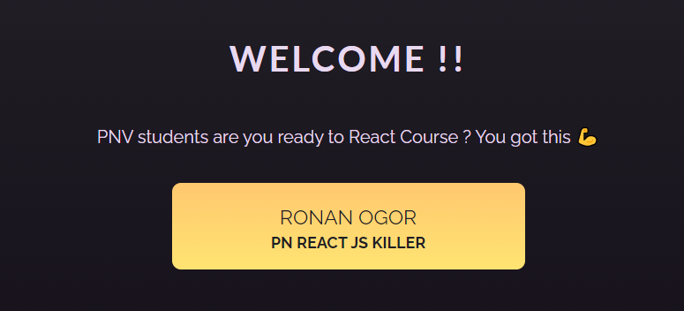

EXERCISE 2
Well done!
But now we have 2 people to display using this User Component: Vinh and My Ngo!

Note: you CANNOT create 2 components, you need to use the user component and pass data to this component

The finished app could look like this:


App will provide a user data to each User component:
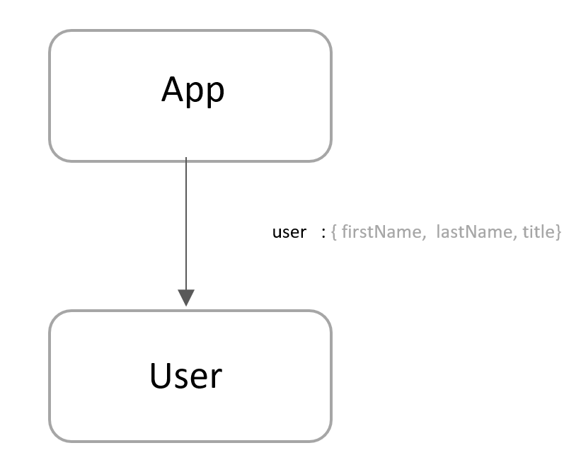

EXERCISE 3
Amazing!
But now we need to display a bigger list of PNV teachers, using this User Component…
The data comes from teachers.js and we already imported this list.

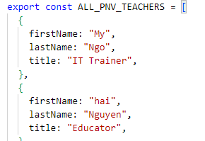
All you need is to loop on this list now and create a User component for each teacher.

Need help? You can read this doc to render lists with a loop

The finished app could look like this:


EXERCISE 4
Amazone!

Now we want to display a list of places.
- The places come from data.js and we already imported this list.
- Each place shall be displayed using the Place component

The mapping between Place component attribute and the data is the following one:
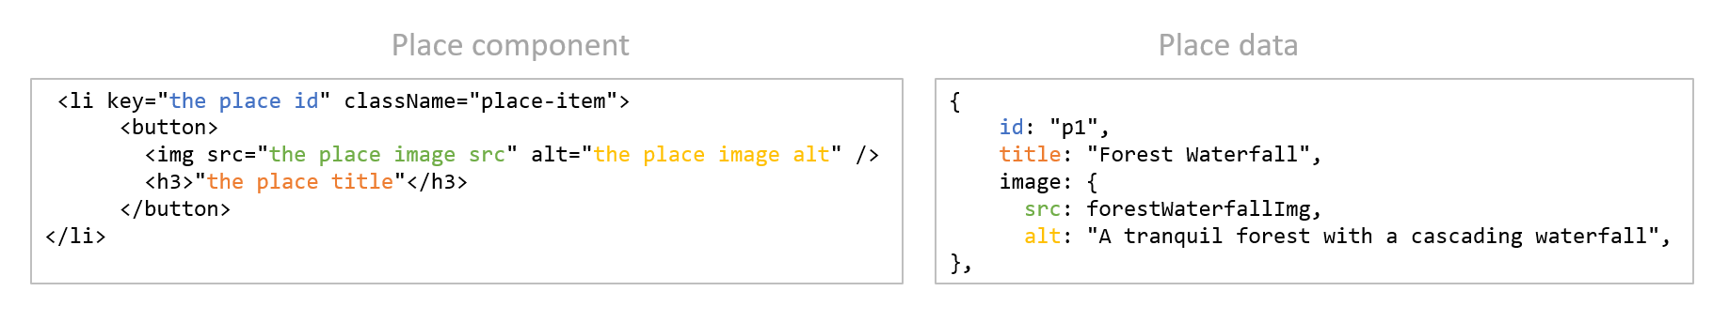

The finished app could look like this
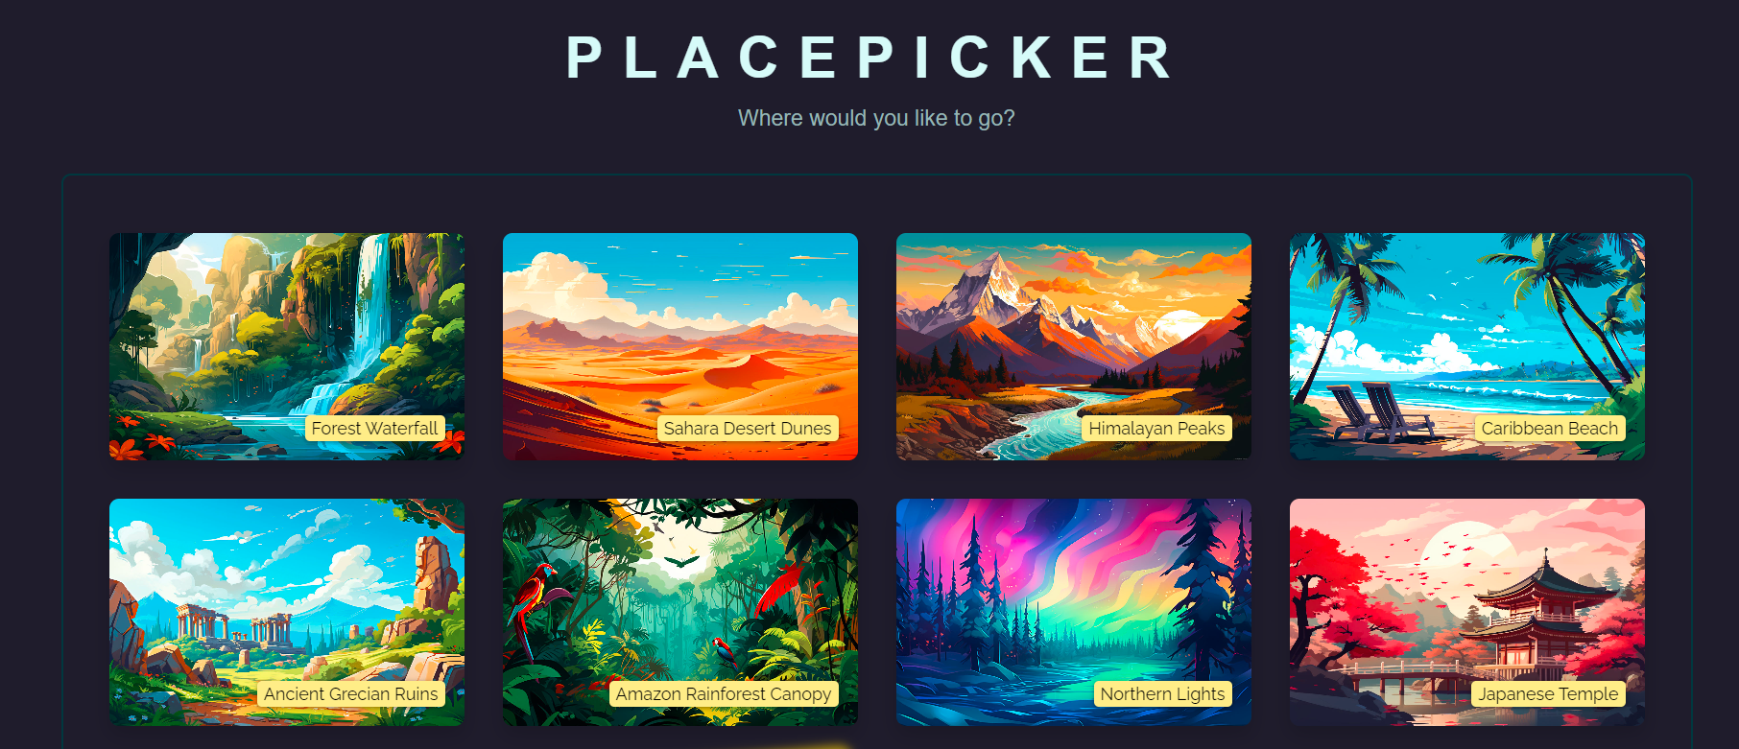

App will provide a place data to each Place component:
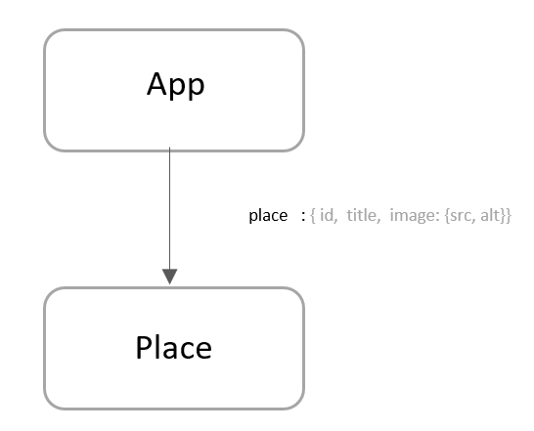

EXERCISE 5
Amazooooooooooooone!

For this last exercise, you need to show your creativity!

- You need to start from an empty app.
- You are free to choose your design and content.

- Your app shall display a list of cards using a Card component. Each card shall contain:
- A picture of someone or something
- Extra information (for example: name, hobbies, gender, address, price…)

- All data shall be stored in the file: data.js

 Are you lost in CSS and HTML?
We have provided an example of HTML/CSS code in the following folder: html-sample-code

Example

App will use a Card component to display the items:
